PRACTICAL ASSESSMENT TASK 1: SUBTASK 1: WORKSHEET 1
Create GitHub Account
Student’s surname and First name/s | MKHAMBI LESEGO ELIAS
Student’s ID number | 0408066049086
Class group | L3
Assessment date
Your GitHub username.
LOKHUNJA

GitHub profile page screenshot.
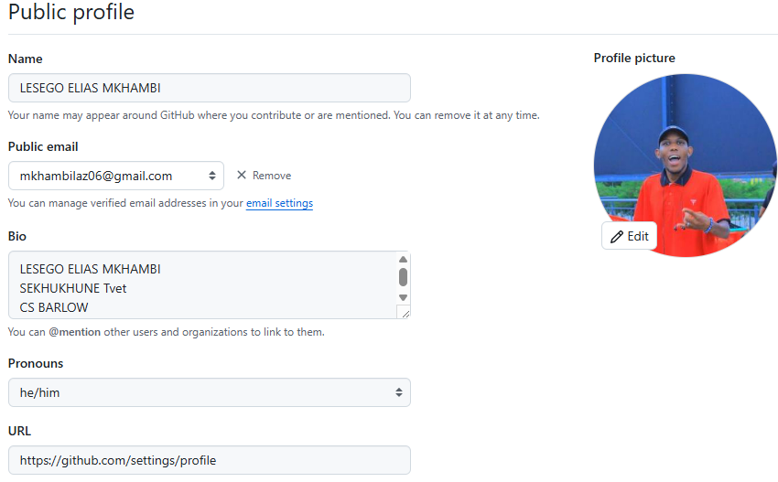
GitHub profile link.
https://github.com/settings/profile

PRACTICAL ASSESSMENT TASK 1: SUBTASK2: WORKSHEET 2
Create GitHub Account
Student’s surname and First name/s | MKHAMBI LESEGO ELIAS
Student’s ID number | 0408066049086
Class group
Assessment date
IPO chart
INPUT | PROCESSING | OUTPUT
TEMP 1 | CALC INCREASE= TEMP2 – TEMP 1 | REDUCE FRYING HEAT
TEMP 2 | CHECK IF INCREASE > 50 | INCREASE FRYER HEAT
TEMP 3 | CHECK IF TEMP 3 IS BETWEEN 150 - 200 | START FRYING THE OIL IS READY

Flowchart
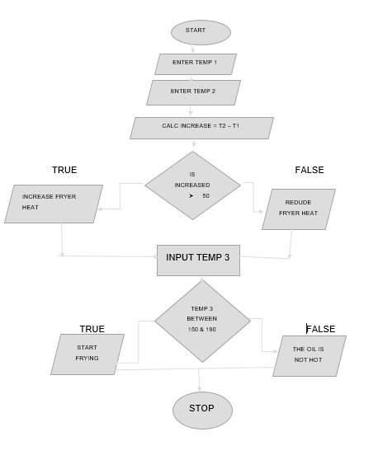
C++ program source code.
#include <iostream>
using System.Collections.Specialized;
using System.ComponentModel.Design;
using System.ComponentModel.Design.Serialization;

int main ()
{
int temp 1, temp 2, temp 3;
int increase;
Cout << "Enter first temperature": "
cin >> temp 2;

if (increase > 50)
count << "Reduce fryer heat" << endl;
else if (increase < 10 )
Cout << "Increase fryer heat" << endl;

cout << "Enter third temperature: ";
Cin >> temp 3;

if (temp 3 >= 150 && temp 3 <= 200)
cout << "Start frying Magwinyas" << endl;
else
cout << "Oil not ready for frying" << endl;
return = 0

}

GitHub link.
LOKHUNJA/-pat1-subtask2- 1 commit
Commit Screenshot
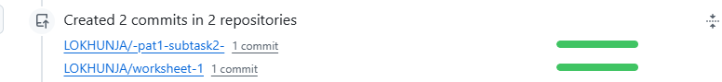

PRACTICAL ASSESSMENT TASK: SUBTASK3: WORKSHEET 3
Create GitHub Account
Student’s surname and First name/s | MKHAMBI LESEGO ELIAS
Student’s ID number | 0408066049086
Class group
Assessment date
C++ program source code.
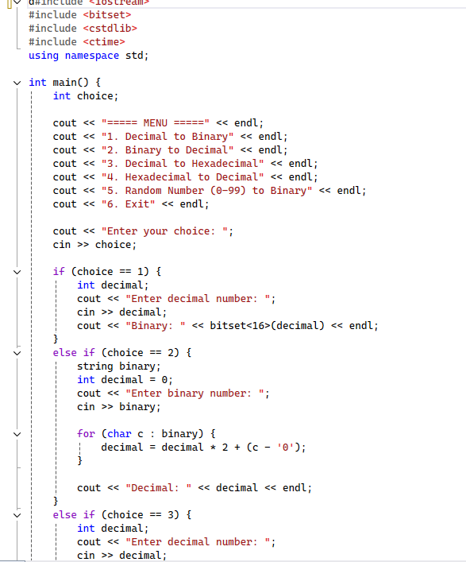

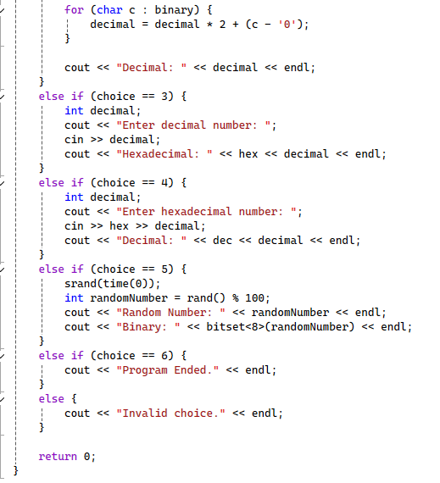

Algorithms designed
Include a brief explanation of the algorithms designed for both conversions.

ALGORITHM

START
1.SHOW MENU
2.ASK USER TO CHOOSE BETWEEN 1; 2; 3 OR 4
3.IF USER CHOOSES 1
-ENTER DECIMAL NUMBER
-CONVERT TO BINARY
-DISPLAY BINARY
4.IF USER CHOOSES 2
-ENTER BINARY NUMBER
-CONVERT TO DECIMAL
-DISPLAY DECIMAL
5.IF USER CHOOSES 3
-ENTER DECIMAL
-CONVERTTO HEXADECIMAL
-DISPLAY HEXADECIMAL
6.IF USER CHOOSES 4
-ENTER HEXADECIMAL
-CONVERT TO DECIMAL
-DISPLAY DECIMAL
7.IF USER CHOOSES 5
-GENERATE A RENDOM NUMBER BETWEEN O-99
-CONVERT TO BINARY
-DISPLAY BINARY
8.EXIT

Student’s Pledge
**Anti-Plagiarism Pledge for Introduction to Technical Programming**

I, __LESEGO ELIAS MKHAMBI______________________, as a dedicated student of Introduction to Technical Programming, hereby solemnly pledge to uphold the principles of academic integrity, honesty, and originality throughout the duration of the conduct of the PAT and ISAT. I understand the importance of maintaining the highest ethical standards in my academic work, and I commit to the following:

- **Original Work:** I pledge that all work I submit for this course, including assignments, reports, and projects, will be entirely my own original work, created specifically for this class.

- **No Plagiarism:** I will not engage in any form of plagiarism, including but not limited to copying content from the internet, fellow students, or any other external sources without proper citation. I understand that plagiarism is a serious academic offense and will not be tolerated.

- **Proper Citation:** If I use external sources or reference materials in my work, I will cite them appropriately using the citation style specified by the instructor. I will give credit to the original authors and sources to acknowledge their contributions to my work.

- **Respect for Intellectual Property:** I will respect the intellectual property rights of others and adhere to all copyright laws when using external sources in my assignments or projects.

- **No Unauthorized Sharing:** I will not share my work with other students who might use it inappropriately, nor will I seek or accept work from others to submit as my own.

- **Academic Honesty:** I will report any suspected instances of academic dishonesty to the instructor or appropriate authority and support the maintenance of academic integrity within the class.

By taking this pledge, I am committed to maintaining the highest standards of academic integrity, and I understand that any violation of this pledge may result in academic consequences, including but not limited to failing grades or disciplinary action. I pledge to do my best to uphold these principles and promote a culture of academic honesty and excellence within our community.

Student details: ___0408066049086_______________________
Signature: _____L.E_________________________
Date: __________________________________
Student’s Declaration of Authenticity
Student surname and  initials | MKHAMBI L.E | ID  Number | 0408066049086
Subject | Introduction to Technical Programming
Select 1  - Practical Assessment Task One (PAT 1)  - Practical Assessment Task Two (PAT 2)  - Integrated Summative Assessment Task (ISAT) |  | Lecturer
I hereby declare that the contents of this assessment task are my own original work (except where there is clear acknowledgement and appropriate reference to the work of others) and have not been plagiarised, copied from someone else or previously submitted for assessment by anyone.

_____L.E____________________ ___ / ___ /
SIGNATURE OF STUDENT DATE

